|  |  |
| --- | --- |
|  | 2814ICT – Data Management  7003ICT – Database Design  School of Information & Communication Technology  Trimester 1, 2021  **Assignment Part 2:**  **Implementing a Database for BigM** |

**ASSIGNMENT TITLE: Analysing ERDs and Writing corresponding SQL statements for BigM’s Database.**

|  |  |  |
| --- | --- | --- |
| **Group ID** | **011** | |
| **Student 1** | **s-number: s5196431** | **Full name: Duwon Ha** |
| **Student 2** | **s-number: s5203114** | **Full name: Kavya Krishnakumar** |
| **Student 3** | **s-number: s5213262** | **Full name: Shinzo Tanimoto** |
| **Course Code: 2814ICT** | | **Workshop/Lab day & time: Friday 9:00am – 10:45am** |
| **Tutor’s name: Emon Kumar Dey** | | **Date submitted: 25/05/2021** |

Contents

**List of Illustrations** 2

**Acknowledgements** 2

**Task 1: Creating SQL Tables** 3

**Task 2: Inserting Records** 5

**Task 3: SQL Queries** 7

**Task 4: Inserting Additional Data** 12

# 

# **List of Illustrations**

|  |  |
| --- | --- |
| **Illustration Name** | **Page Number** |
| Table 1 | 7 |
| Table 2 | 7 |
| Table 3 | 8 |
| Table 4 | 8 |
| Table 5 | 8 |
| Table 6 | 9 |
| Table 7 | 9 |
| Table 8 | 10 |
| Table 9 | 10 |
| Table 10 | 11 |

**Acknowledgements**

1. **Emon Kumar Dey**

# **Task 1: Creating SQL Tables**

CREATE DATABASE IF NOT EXISTS BigM_s5213262;

USE bigm_s5213262;

SHOW TABLES;

CREATE TABLE IF NOT EXISTS CUSTOMER(

Cust_Number INT PRIMARY KEY AUTO_INCREMENT,

Cust_Fname VARCHAR(30),

Cust_Lname VARCHAR(30),

Cust_Phone CHAR(10)

) ENGINE=InnoDB;

CREATE TABLE IF NOT EXISTS PRODUCT(

Prod_Num INT PRIMARY KEY AUTO_INCREMENT,

Prod_Desc VARCHAR(30),

Prod_Size VARCHAR(30),

Prod_Price DECIMAL

) ENGINE=InnoDB;

CREATE TABLE IF NOT EXISTS DEPARTMENT(

Dept_ID INT PRIMARY KEY AUTO_INCREMENT,

Dept_Name VARCHAR(30)

) ENGINE=InnoDB;

CREATE TABLE  IF NOT EXISTS EMPLOYEE(

Emp_ID INT PRIMARY KEY AUTO_INCREMENT,

Emp_FName   VARCHAR(30),

Emp_LName   VARCHAR(30),

Emp_Phone   INTEGER,

Emp_DoB     DATE,

Emp_StartDate   DATE,

Emp_TaxFNum   INTEGER,

Emp_HourlySalary DECIMAL(10,2),

StrDept_ID INT,

SupervisorID INT

) ENGINE = InnoDB;

CREATE TABLE IF NOT EXISTS STORE(

Str_Num INT PRIMARY KEY AUTO_INCREMENT,

Str_Name VARCHAR(50),

Str_Phone CHAR(10),

Str_Fax CHAR(10),

Str_Email VARCHAR(40),

StoreManagerID INT,

SupStore_Num INT,

FOREIGN KEY (StoreManagerID) REFERENCES EMPLOYEE(Emp_ID),

FOREIGN KEY (SupStore_Num) REFERENCES STORE(Str_Num)

) ENGINE=InnoDB;

CREATE TABLE IF NOT EXISTS CUSTOMERORDER(

CustOrd_ID INT PRIMARY KEY AUTO_INCREMENT,

CustOrd_Date DATE,

Cust_Number INT NOT NULL,

Str_Num INT NOT NULL,

FOREIGN KEY (Cust_Number) REFERENCES CUSTOMER (Cust_Number),

FOREIGN KEY (Str_Num) REFERENCES STORE (Str_Num)

) ENGINE=InnoDB;

CREATE TABLE IF NOT EXISTS ORDERLINE(

CustOrd_ID INT,

Prod_Num INT,

OrdLn_DateArrived DATE,

OrdLn_DatePicked DATE,

OrdLn_Qnty INT,

PRIMARY KEY (CustOrd_ID, Prod_Num),

FOREIGN KEY (CustOrd_ID) REFERENCES CUSTOMERORDER(CustOrd_ID),

FOREIGN KEY (Prod_Num) REFERENCES PRODUCT (Prod_Num)

) ENGINE=InnoDB;

CREATE TABLE IF NOT EXISTS STOREDEPARTMENT(

StrDept_ID INT PRIMARY KEY AUTO_INCREMENT,

StrDept_Phone CHAR(10),

StrDept_Email VARCHAR(40),

DeptSupervisorID INT,

Str_Num INT,

Dept_ID INT,

FOREIGN KEY (DeptSupervisorID) REFERENCES EMPLOYEE(Emp_ID),

FOREIGN KEY (Str_Num) REFERENCES STORE(Str_Num),

FOREIGN KEY (Dept_ID) REFERENCES DEPARTMENT(Dept_ID)

) ENGINE=InnoDB;

ALTER TABLE EMPLOYEE

ADD FOREIGN KEY (StrDept_ID) REFERENCES STOREDEPARTMENT (StrDept_ID);

ALTER TABLE EMPLOYEE

ADD FOREIGN KEY (SupervisorID) REFERENCES EMPLOYEE (Emp_ID);

CREATE TABLE IF NOT EXISTS PAYSLIP(

Pay_ID INT PRIMARY KEY AUTO_INCREMENT,

Pay_date DATE,

Pay_num_of_hours INT NOT NULL,

Pay_amount_gross DOUBLE NOT NULL,

Emp_ID INT NOT NULL,

Str_Num INT NOT NULL,

FOREIGN KEY (Emp_ID) REFERENCES EMPLOYEE (Emp_ID),

FOREIGN KEY (Str_Num) REFERENCES STORE (Str_Num)

) ENGINE=InnoDB;

CREATE TABLE IF NOT EXISTS INVENTORY(

ProductNum INT,

Str_Num INT,

Inv_QntyOnHand INT NOT NULL,

Inv_QtyOrdered INT NOT NULL,

PRIMARY KEY (ProductNum, Str_Num),

FOREIGN KEY (ProductNum) REFERENCES PRODUCT (Prod_Num),

FOREIGN KEY (Str_Num) REFERENCES STORE (Str_Num)

) ENGINE=InnoDB;

# **Task 2: Inserting Records**

USE bigm_s5213262;

INSERT INTO CUSTOMER VALUES

(NULL, 'Buffy', 'Winters', '0412345678'),

(NULL, 'Duwon', 'Ha', '0455803205'),

(NULL, 'Kavya', 'Krishnakumar', '0489789774'),

(NULL, 'Jack', 'Tomlinson', '0484787854'),

(NULL, 'Shinzo', 'Tanimoto', '0435607767'),

(NULL, 'Jone', 'Tyler', '0445679873'),

(NULL, 'Princess', 'Ha', '0413247477'),

(NULL, 'David', 'Bieber', '0412522377');

INSERT INTO PRODUCT VALUES

(NULL, 'Gardening Scissors','Medium', 10),

(NULL, 'Shirt', 'Medium', 30),

(NULL, 'Kitchen Knives Set Deluxe', 'Medium', 120),

(NULL, 'Basketball Regulation Size', 'Small', 350),

(NULL, 'Nickson James Hits', 'Small', 50),

(NULL, '100% Polyester sleepwear', 'Large', 120),

(NULL, 'Jordan Shoes', 'Small', 700);

INSERT INTO DEPARTMENT VALUES

(NULL, 'Sports'),

(NULL, 'Clothes'),

(NULL, 'Kitchen'),

(NULL, 'Homeware'),

(NULL, 'Garden');

INSERT INTO EMPLOYEE(Emp_ID, Emp_FName, Emp_LName, Emp_Phone, Emp_DoB, Emp_StartDate, Emp_TaxFNum, Emp_HourlySalary) VALUES

(NULL, 'Koupa', 'Taylor', '0321224224', '2002-03-12', '2020-05-02', 12345678, 30),

(NULL, 'Ben', 'Flint', '0434551234', '1999-06-12', '2020-05-02', 15125677, 60),

(NULL, 'Harry', 'Robin', '0449879343', '2002-07-07', '2020-09-12', 98765432, 30),

(NULL, 'Elizabeth', 'Then', '0421252322', '1998-03-23', '2021-03-02', 9823124, 30),

(NULL, 'Jordan', 'Nickson', '0414279846', '1989-08-01', '2010-04-20', 09872525, 40),

(NULL, 'Jason', 'Micheal', '0412340987', '1997-05-04', '2019-12-12', 102938475, 30);

INSERT INTO STORE(Str_Num, Str_Name, Str_Phone, Str_Fax, Str_Email, StoreManagerID) VALUES

(NULL, 'Elizabeth-Street-Branch', '0312452524', '0145252434', 'elizabeth@bigm.au', 3),

(NULL, 'Adelaide-Street-Branch', '0124352321', '291232423', 'adelaide@bigm.au', 1),

(NULL, 'Southbank-Branch', '023674845', '026882683', 'southbank@bigm.au', 4),

(NULL, 'Surfers-Paradise-Branch', '0123452352', '2948274817', 'surfers.paradise@bigm.au', 5),

(NULL, 'Mount-Gravatt-Branch', '0937192322', '2982142351', 'mountGravatt@bigm.au', 6);

INSERT INTO CUSTOMERORDER VALUES

(NULL, '2021-05-03', 1, 1),

(NULL, '2021-05-07', 2, 2),

(NULL, '2021-05-22', 3, 3),

(NULL, '2021-05-12', 4, 4),

(NULL, '2021-05-25', 5, 5),

(NULL, '2021-05-30', 6, 3),

(NULL, '2021-05-22', 7, 4);

INSERT INTO ORDERLINE VALUES

(1, 1, '2017-06-03', '2017-06-04', 3),

(2, 2, '2021-06-07', '2021-06-09', 2),

(3, 3, '2015-06-22', '2015-06-23', 2),

(4, 4, '2021-06-12', '2021-06-13', 1),

(5, 5, '2014-06-17', '2014-06-20', 3);

INSERT INTO STOREDEPARTMENT VALUES

(NULL, '1234567891', 'elizabeth.kitchen@bigm.au', 3, 1, 3),

(NULL, '1209384756', 'adelaide.sports@bigm.au', 5, 2, 1),

(NULL, '1252156215', 'southbank.kitchen@bigm.au', 4, 3, 3),

(NULL, '9830484921', 'surfers.paradice.homewear@bigm.au', 1, 4, 4),

(NULL, '8273182931', 'mountGravatt.garden@bigm.au', 6, 5, 5),

(NULL, '2910242312', 'elizabeth.garden@bigm.au', 3, 1, 5),

(NULL, '2923144212', 'adelaide.garden@bigm.au', 2, 2, 5);

UPDATE EMPLOYEE SET StrDept_ID = 4 WHERE Emp_ID = 1;

UPDATE EMPLOYEE SET StrDept_ID = 7 WHERE Emp_ID = 2;

UPDATE EMPLOYEE SET StrDept_ID = 1 WHERE Emp_ID = 3;

UPDATE EMPLOYEE SET StrDept_ID = 3 WHERE Emp_ID = 4;

UPDATE EMPLOYEE SET StrDept_ID = 2 WHERE Emp_ID = 5;

UPDATE EMPLOYEE SET StrDept_ID = 5 WHERE Emp_ID = 6;

UPDATE STORE SET SupStore_Num = 2 WHERE Str_Num = 1;

UPDATE STORE SET SupStore_Num = 3 WHERE Str_Num = 2;

UPDATE STORE SET SupStore_Num = 4 WHERE Str_Num = 3;

UPDATE STORE SET SupStore_Num = 5 WHERE Str_Num = 4;

UPDATE STORE SET SupStore_Num = 1 WHERE Str_Num = 5;

INSERT INTO PAYSLIP VALUES

(NULL, '2021-06-30', 80, 2400 ,1,2),

(NULL, '2021-06-30', 72, 4320, 2,2),

(NULL, '2021-06-30', 50, 1500, 3,1),

(NULL, '2021-06-30', 60, 1800, 4,3),

(NULL, '2021-06-30', 80, 3200, 5,4),

(NULL, '2021-06-30', 68, 2040, 6,5);

INSERT INTO INVENTORY VALUES

(2,2,3,4),

(1,3,4,5),

(3,2,1,10),

(2,3,10,2),

(5,4,2,4),

(5,3,2,2),

(6,5,5,2),

(7,2,5,2);

# 

# **Task 3: SQL Queries**

**Query 1:** List of names of all employees sorted by their hourly salary.

SELECT CONCAT(Emp_FName, ' ', Emp_LName) AS ‘Name’

FROM EMPLOYEE

ORDER BY Emp_HourlySalary;

**Output table:**

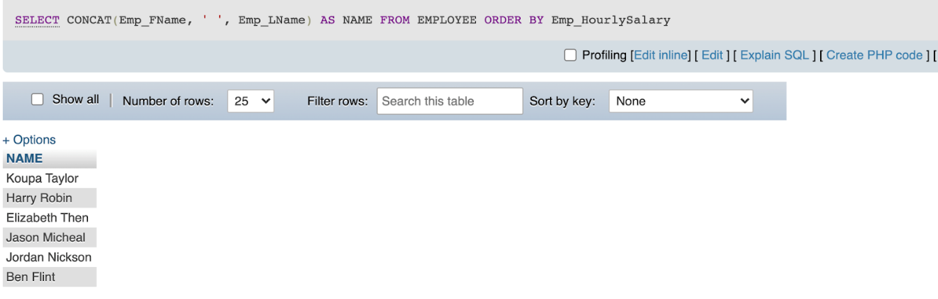

Table

**Query 2:**  The date on which the most recent customer order has been made. The customer’s name and date of the order will be sufficient.

SELECT CONCAT(C.Cust_FName, ' ' , C.Cust_LName) AS 'Name', O.CustOrd_Date AS 'Date Of The Order'

FROM CUSTOMER AS C, CUSTOMERORDER AS O

WHERE C.Cust_Number = O.Cust_Number

Order by CustOrd_Date DESC

limit 0,1;

**Output table:**

Table 2

**Query 3:** List of all the store names and their manager names, sorted in dictionary order of the store name.

SELECT S.Str_Name AS 'Store Name', CONCAT(E.Emp_FName, ' ', E.Emp_LName) AS 'Name'

FROM STORE AS S, EMPLOYEE AS E

WHERE S.StoreManagerID = E.Emp_ID

ORDER BY S.Str_Name ASC;

**Output table:**

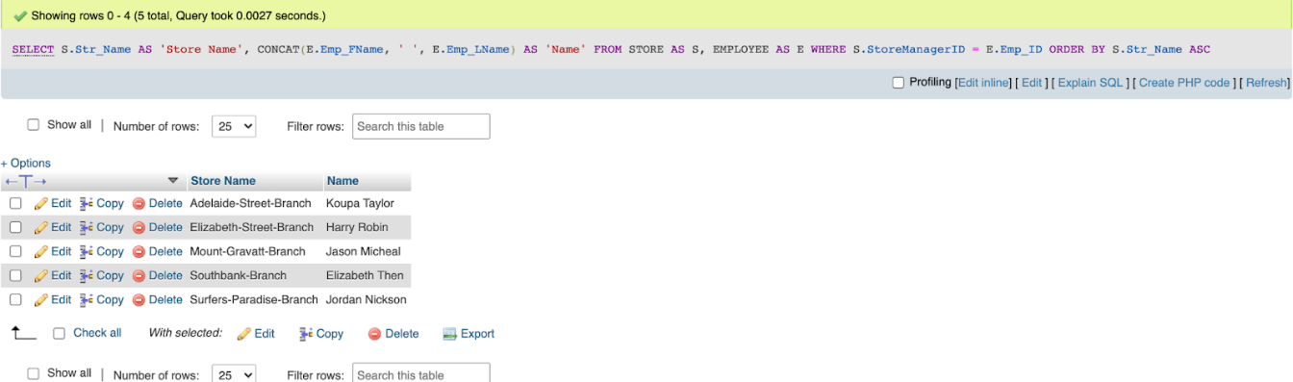

Table 3

**Query 4:** A list of all customers that have not placed an order yet. Displaying customer number and name will be sufficient.

SELECT C.Cust_Number AS 'Custom Number', CONCAT(C.Cust_FName, ' ', C.Cust_LName) AS 'Name'

FROM CUSTOMER AS C

WHERE C.Cust_Number NOT IN (SELECT Cust_Number FROM CUSTOMERORDER);

**Output table:**

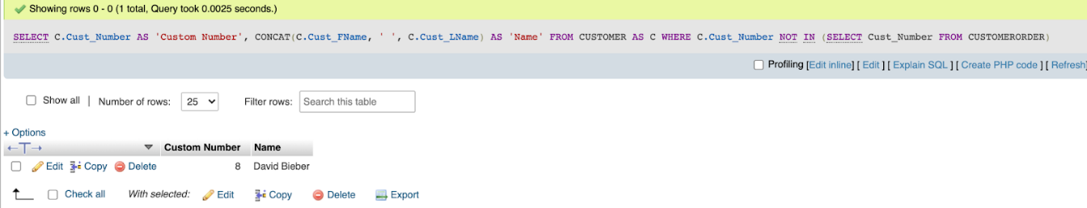

Table 4

**Query 5:**  A list containing the name of employees, who work as supervisors for ‘Sports’ departments in various stores. Show store names and the supervisors of Sports department.

SELECT S.Str_Name AS 'Store Name', CONCAT(E.Emp_FName, ' ', E.Emp_LName) AS 'Supervisor Name'

FROM STORE AS S, EMPLOYEE AS E, STOREDEPARTMENT AS SD

WHERE SD.DeptSupervisorID = E.Emp_ID

AND SD.Dept_ID = (SELECT Dept_ID FROM DEPARTMENT WHERE Dept_Name = 'Sports')

AND SD.Str_Num = S.Str_Num;

**Output table:**

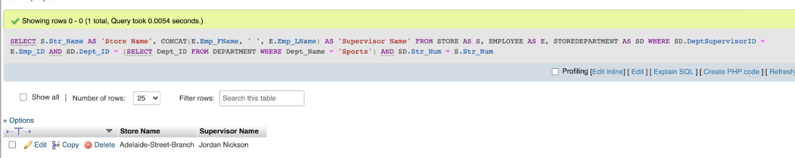

Table 5

**Query 6:** A list containing the total quantity on hand for each product (product number and description) regardless of stores.

SELECT P.Prod_Num AS 'Product Number', P.Prod_Desc AS 'Description', SUM(Inv_QntyOnHand) AS 'Quantity On Hand'

FROM PRODUCT AS P, INVENTORY AS I

WHERE P.Prod_Num = I.ProductNum

GROUP BY P.Prod_Num;

**Output table:**

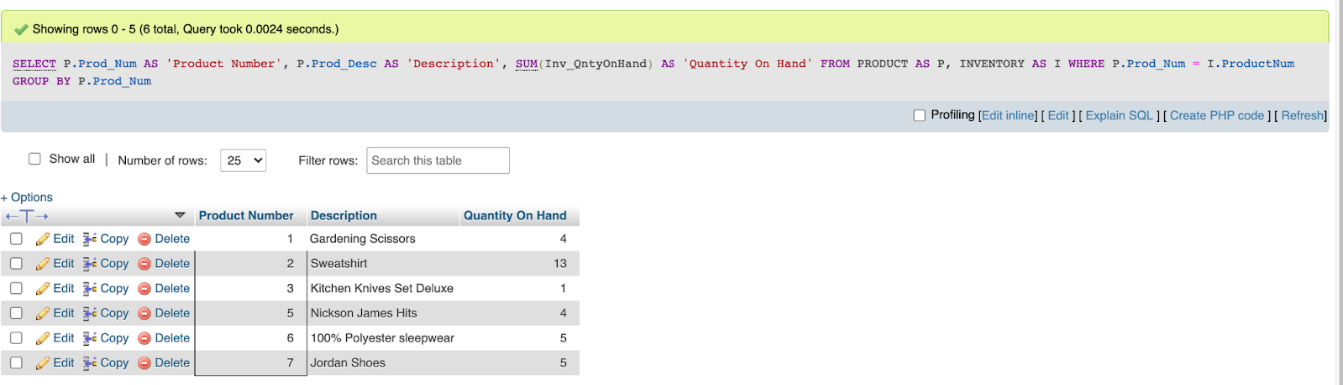

Table 6

**Query 7:** A list showing each product sold (picked) on or before May 20, 2018. Show product number, name and quantity sold, sorted by product number and then quantity sold.

SELECT P.Prod_Num AS 'Product Number', P.Prod_Desc AS 'Description',  SUM(O.OrdLn_Qnty) AS 'Quantity Sold'

FROM ORDERLINE AS O, PRODUCT AS P

WHERE   O.Prod_Num = P.Prod_Num AND OrdLn_DatePicked <= '2018-05-20'

GROUP BY P.Prod_Num

ORDER BY P.Prod_Num, sum(O.OrdLn_Qnty);

**Output table:**

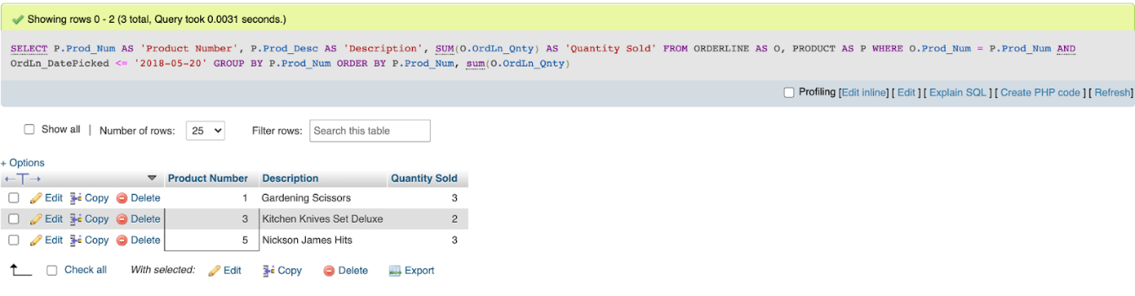

Table 7

**Query 8:** A list of products (show product number, description and price) whose price is less than or equal to the average product price.

SELECT Prod_Num AS 'Product Number', Prod_Desc 'Description', Prod_Price AS '($) Price'

FROM PRODUCT

WHERE Prod_Price <= (SELECT AVG(Prod_Price) FROM PRODUCT);

**Output table:**

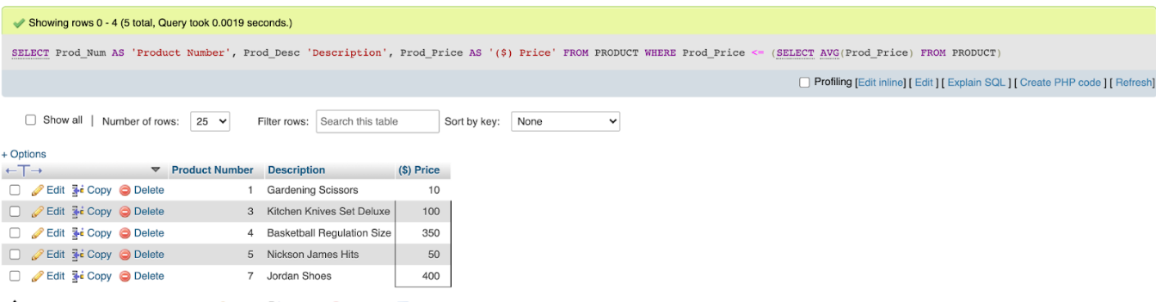

Table 8

**Query 9:**  Increase each employee’s salary by 7.5% and show the updated salary of all employees (name and salary).

UPDATE EMPLOYEE

SET Emp_HourlySalary = Emp_HourlySalary*1.075;

SELECT CONCAT(Emp_FName, ' ', Emp_LName) AS 'Name', Emp_HourlySalary AS 'Hourly Salary'

FROM EMPLOYEE;

**Output table:**

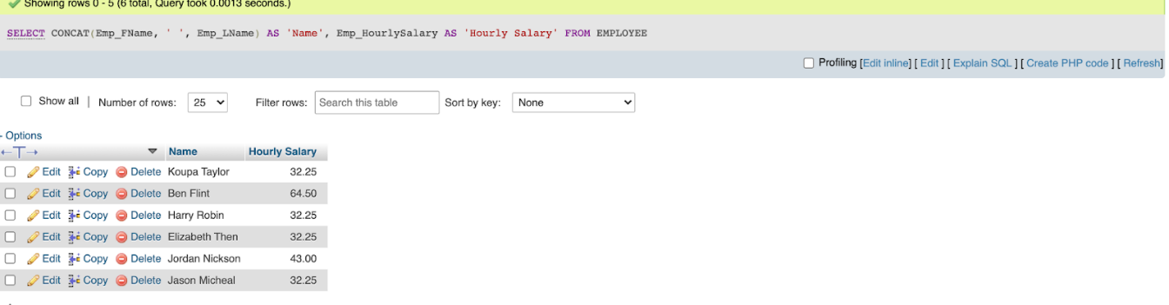

Table 9

**Query 10:**  Show the pay information (employee name, hours paid, amount paid) of all employees in the most recent pay date.

SELECT CONCAT(E.Emp_FName, ' ', E.Emp_LName) AS 'Name', CAST((P.Pay_amount_gross / E.Emp_HourlySalary) AS INT) AS 'Hours Paid', P.Pay_amount_gross AS 'Total Amount Paid'

FROM EMPLOYEE AS E, PAYSLIP AS P

WHERE P.Emp_ID = E.Emp_ID

AND P.Pay_date = (SELECT Pay_date

                  FROM PAYSLIP

                  ORDER BY Pay_date DESC

                  limit 0, 1);

**Output table:**

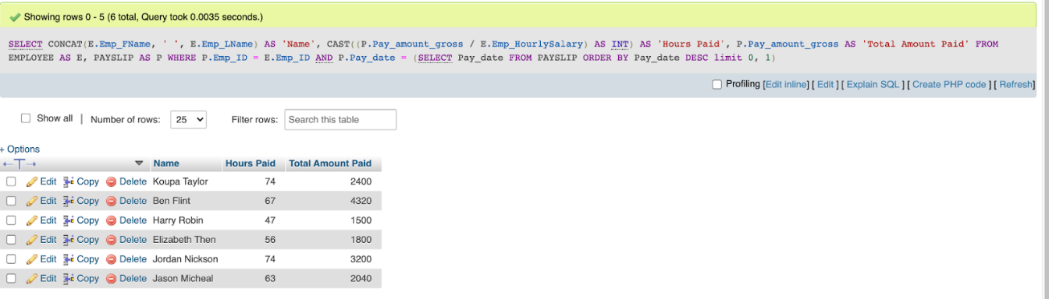

Table 10

# **Task 4: Inserting Additional Data**

USE bigm_s5213262;

INSERT INTO CUSTOMER VALUES

(NULL, 'Daniel', 'Ortega', '0431xxx668');

INSERT INTO CUSTOMERORDER VALUES

(NULL, '2018-09-06', (SELECT Cust_Number FROM CUSTOMER ORDER BY Cust_Number DESC limit 0, 1), 2);

INSERT INTO ORDERLINE VALUES

((SELECT CustOrd_ID FROM CUSTOMERORDER ORDER BY CustOrd_ID DESC limit 0, 1), 2, '2018-09-08', '2018-09-10', 2);

UPDATE INVENTORY

SET Inv_QtyOnHand = Inv_QtyOnHand - (SELECT OrdLn_Qnty FROM ORDERLINE WHERE CustOrd_ID = (SELECT CustOrd_ID FROM CUSTOMERORDER ORDER BY CustOrd_ID DESC limit 0, 1) AND Prod_Num = 2)

WHERE ProductNum = 2

AND Str_Num = 2;

UPDATE INVENTORY

SET Inv_QtyOrdered = Inv_QtyOrdered + (SELECT OrdLn_Qnty FROM ORDERLINE WHERE CustOrd_ID = (SELECT CustOrd_ID FROM CUSTOMERORDER ORDER BY CustOrd_ID DESC limit 0, 1) AND Prod_Num = 2)

WHERE ProductNum = 2

AND Str_Num = 2;